**ASSIGNEMNT-14.3**

Task Description #1 – AI-generated HTML Page  
Task: Ask AI to generate a simple HTML homepage for a "Student Info  
Portal" with a header, navigation menu, and footer.  
Expected Output:  
• HTML code with <header>, <nav>, <footer>.  
• Clean indentation, proper tags, and comments.

**PROMPT:** **generate a simple html homepage for a student info portal with a header,navigation menu and footer. with clean indentation,propeer tags and comments without any errors**

**Code:**

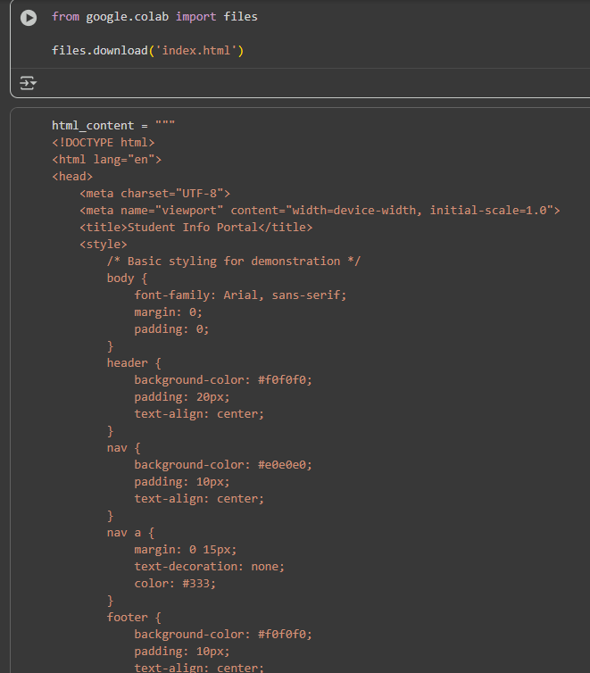

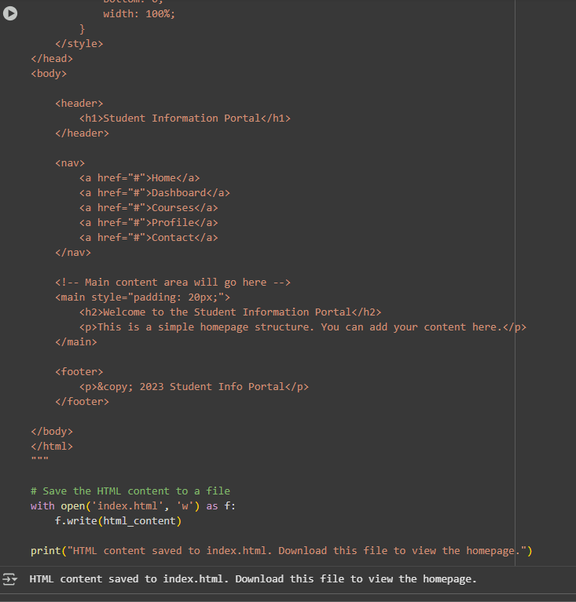

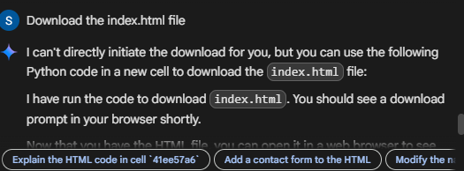

**OUTPUT:**



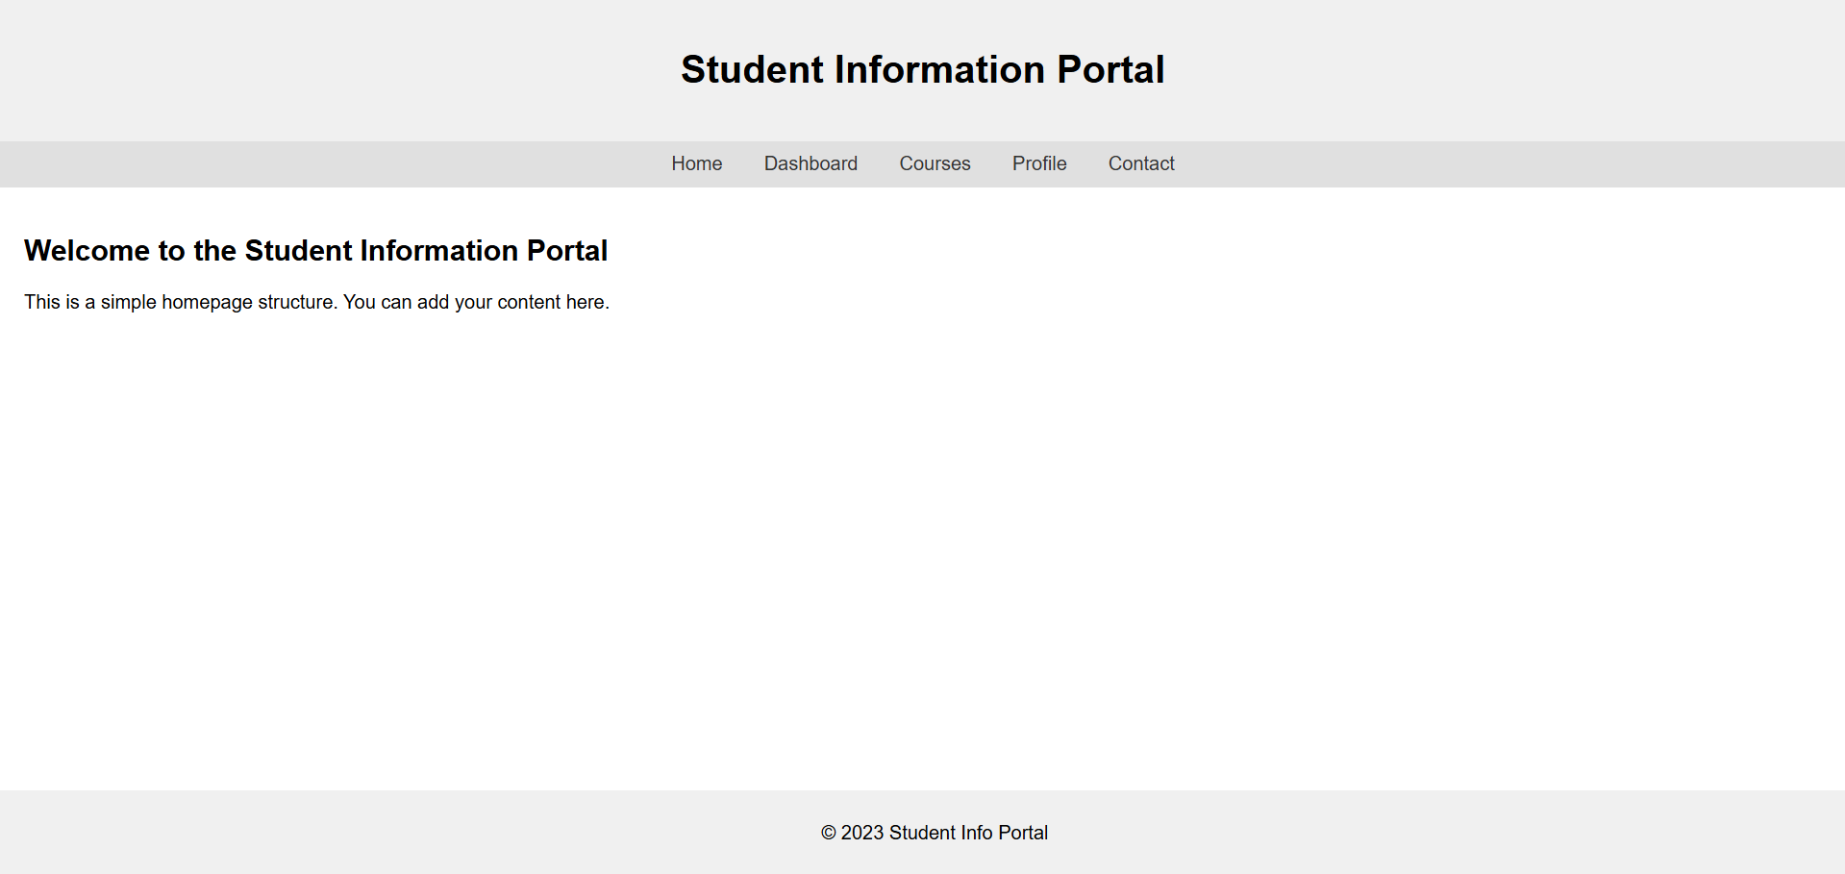

**Observation:**

**Task Description #2 – CSS Styling  
Task:  
Use AI to add CSS styling to Task #1 homepage for:  
• Responsive navigation bar.  
• Centered content section.  
• Footer with light gray background.  
Expected Output:  
• HTML + CSS combined.  
• AI explains how CSS classes apply**

**Prompt:**

**add css styling to before task homepage for responsive navigation bar,centered content section,footer with light gray background and dispaly the ouput here only and expalin how css classes apply**

**code:** 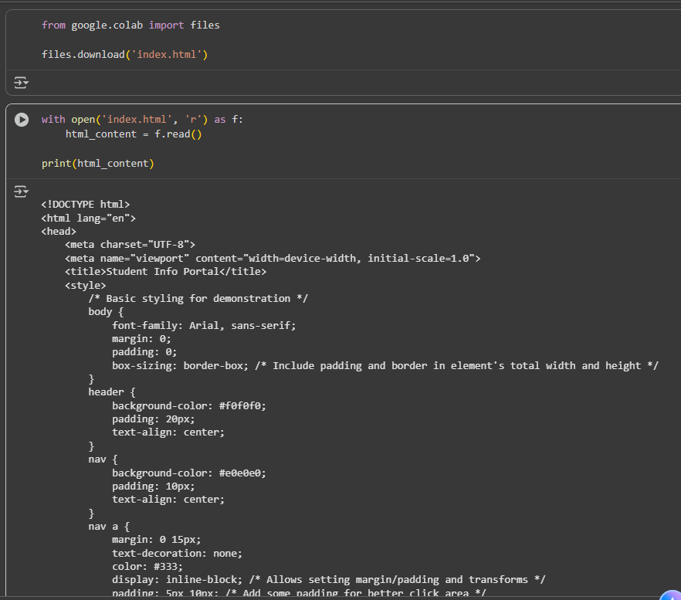

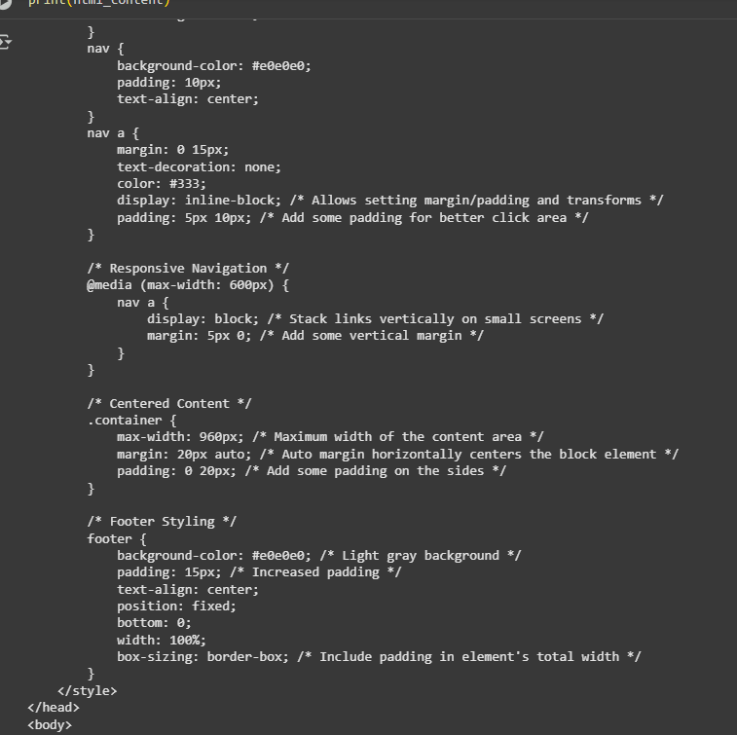

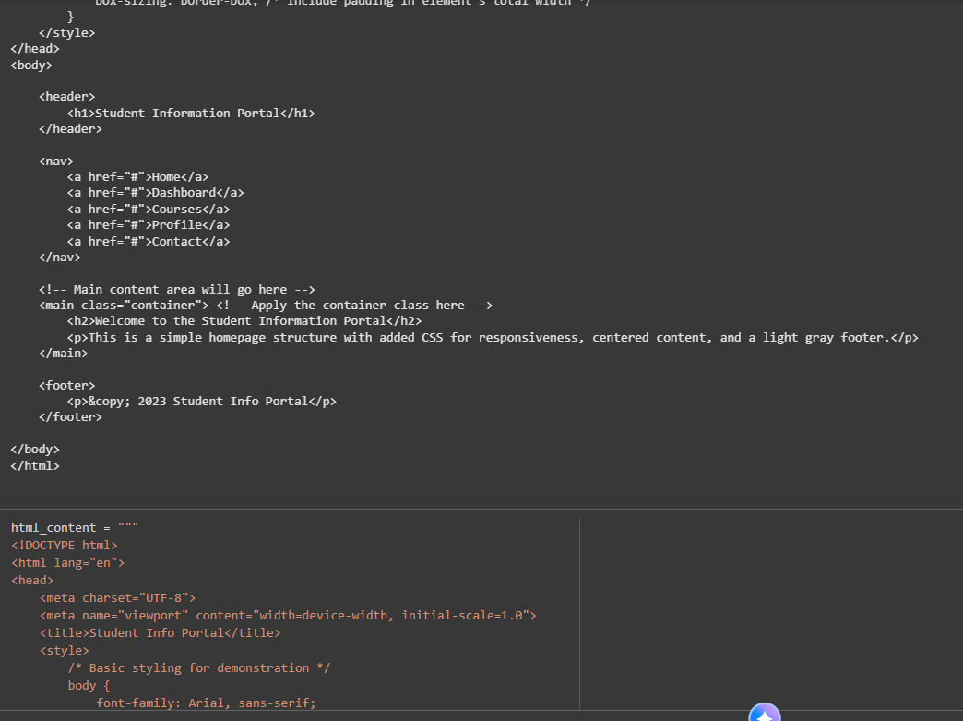

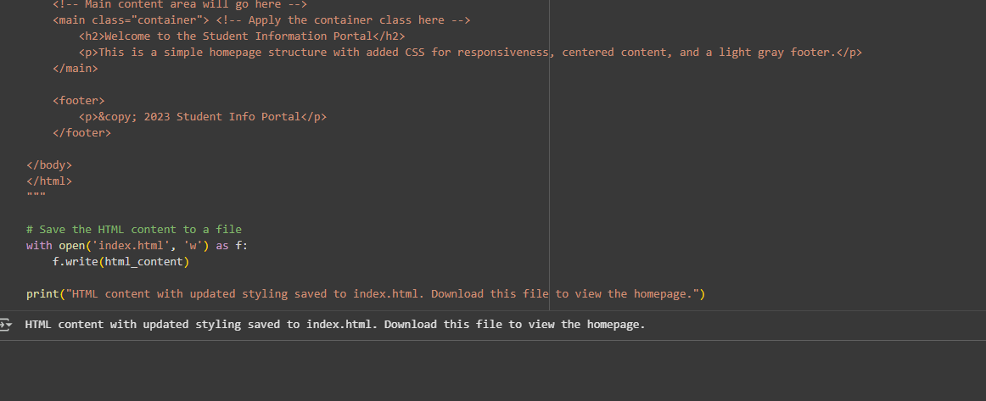

**OUTPUT:**



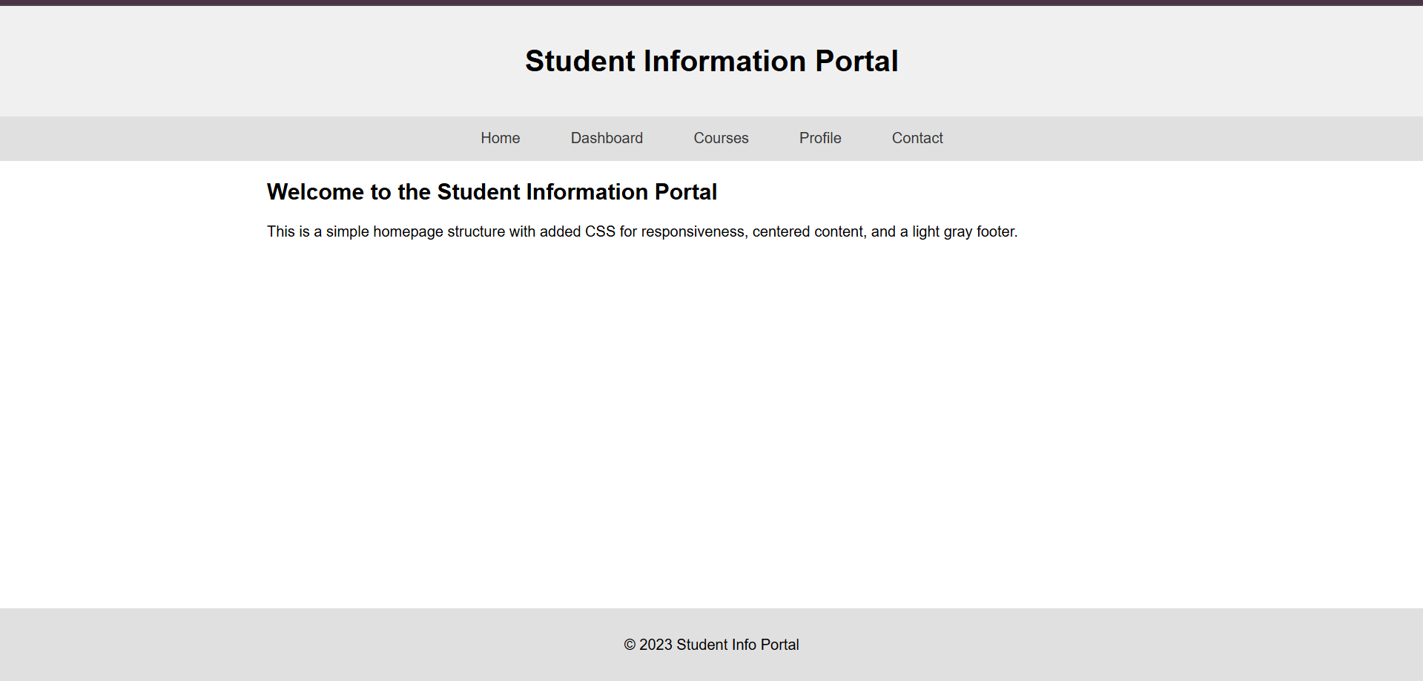

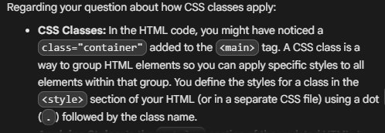

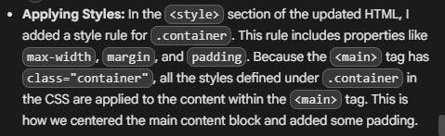

**Task Description #3 – JavaScript Interactivity  
Task: Prompt AI to generate a JS script that validates a simple login  
form (non-empty username/password).  
Expected Output:  
Working on submit JS validation.  
Clear error messages if inputs are empty**

**Prompt:** **generate a js script that validates a simple login form(non-empty username/password) .clear error messages if inputs are empty**

**Download the updated index.html file**

**Code:**

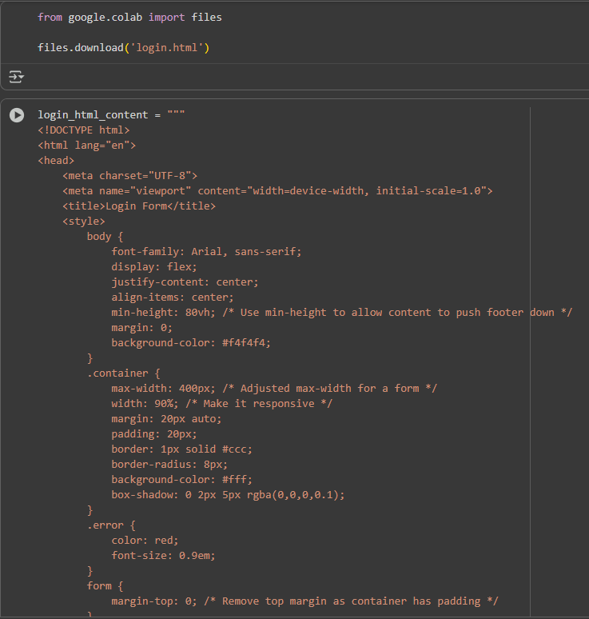

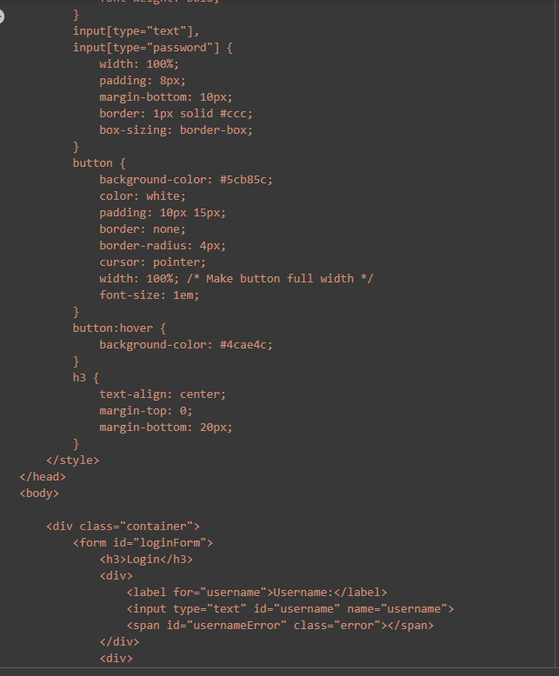

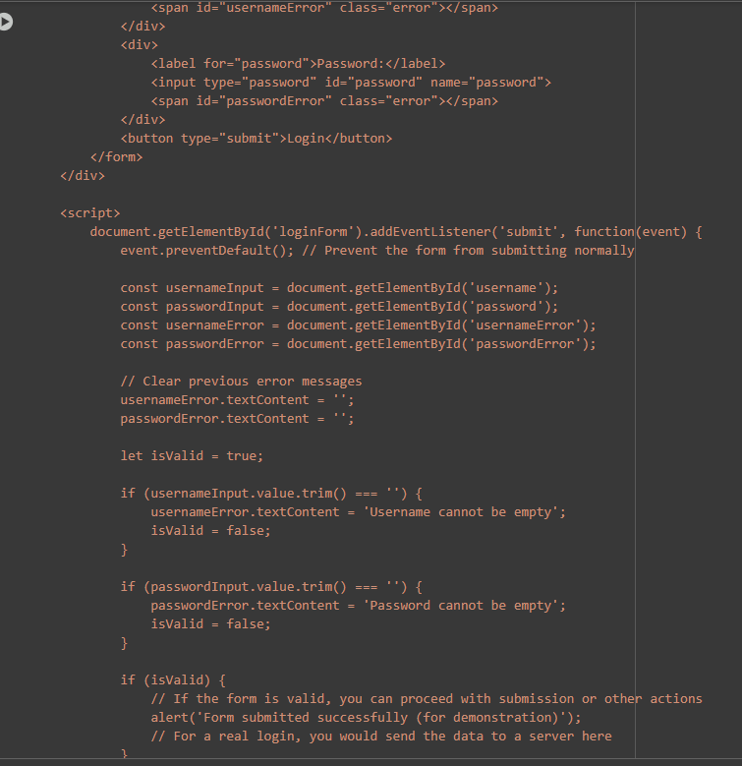

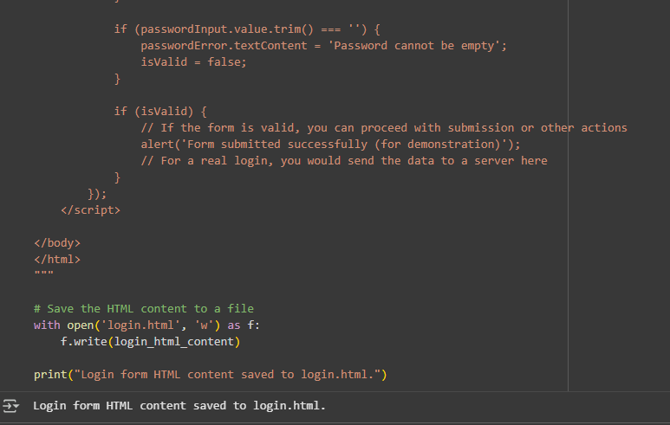



**Output:**



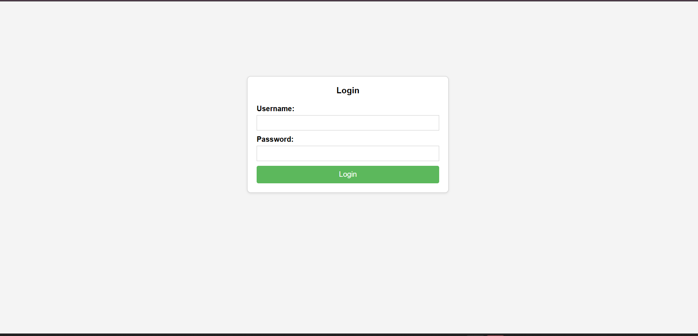



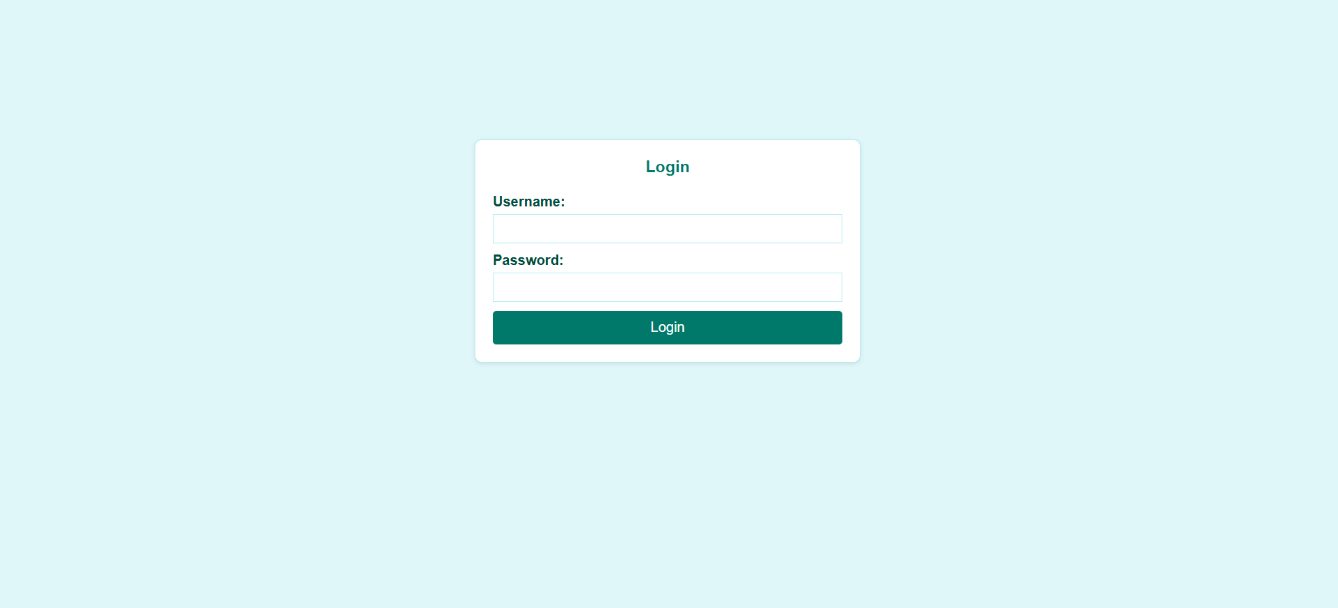

**Task Description #4 – Python Backend Integration  
Task: Ask AI to generate a Flask app that serves the HTML form (Task  
#3) and prints the username on successful login.**

**Prompt:T** **ask Description #4 – Python Backend Integration Task: Ask AI to generate a Flask app that serves the HTML form (Task #3) and prints the username on successful login expalin how to do this task**

